**Task 4**

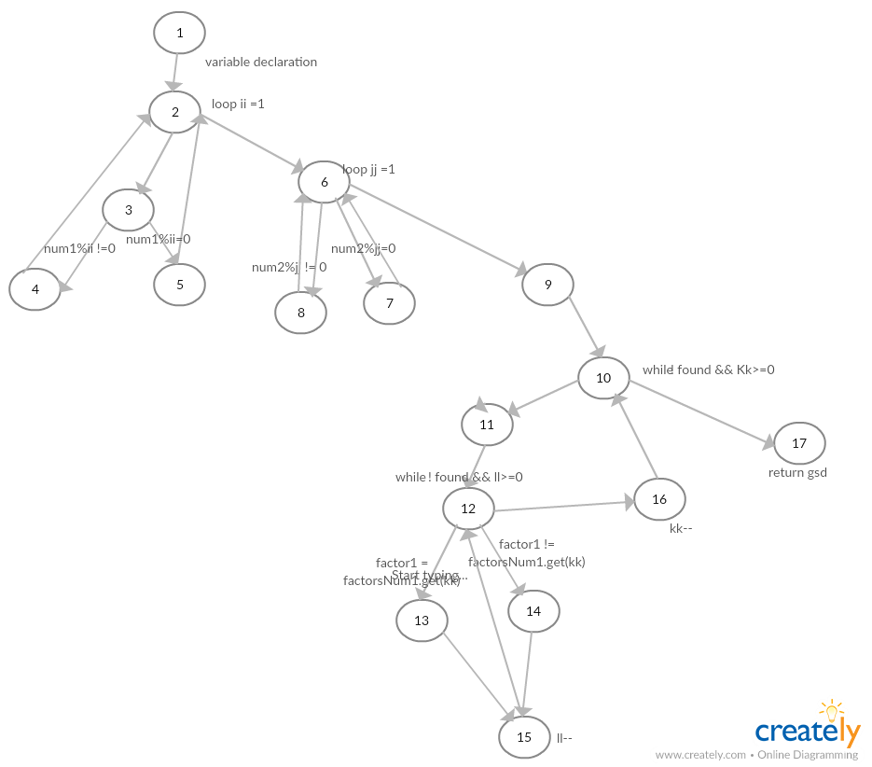

1. **List the test requirements and a test set for:**
2. **(i). All-du-path Coverage.**

[1,2,3,4,2,6,8,6,9,10,11,12,13,15,12,16,10,17]

[1,2,3,5,2,6,8,6,9,10,11,12,13,15,12,16,10,17]

[1,2,3,4,2,6,7,6,9,10,11,12,13,15,12,16,10,17]

[1,2,3,5,2,6,7,6,9,10,11,12,13,15,12,16,10,17]

[1,2,3,4,2,6,8,6,9,10,11,12,14,15,12,16,10,17]

[1,2,3,5,2,6,8,6,9,10,11,12,14,15,12,16,10,17]

[1,2,3,4,2,6,7,6,9,10,11,12,14,15,12,16,10,17]

[1,2,3,5,2,6,7,6,9,10,11,12,14,15,12,16,10,17]

[1,2,6,9,10,17]

**(ii). Prime Path Coverage.**

[1,2,3,4,2,6,8,6,9,10,11,12,13,15,12,16,10,17]

[1,2,3,5,2,6,8,6,9,10,11,12,13,15,12,16,10,17]

[1,2,3,4,2,6,7,6,9,10,11,12,13,15,12,16,10,17]

[1,2,3,5,2,6,7,6,9,10,11,12,13,15,12,16,10,17]

[1,2,3,4,2,6,8,6,9,10,11,12,14,15,12,16,10,17]

[1,2,3,5,2,6,8,6,9,10,11,12,14,15,12,16,10,17]

[1,2,3,4,2,6,7,6,9,10,11,12,14,15,12,16,10,17]

[1,2,3,5,2,6,7,6,9,10,11,12,14,15,12,16,10,17]

**(b) Undertake logic coverage of the given program:**

**(i). List all predicates.**

* !found && KK>= 0
* !found && ll>=0

**(ii). Define all reachability conditions for the predicates defined in part (i).**

* !found && KK>= 0
  + Found must be false and kk should be greater or equal to zero.
* !found && ll>=0
  + Found must be false and ll should be greater or equal to zero

**(iii). List test cases (and expected output) for:**

1) Predicate Coverage

**Test case: 1**

**Title:** Number less than Zero

**Description:**

The first number entered is less than zero.

**Test steps:**

Enter 1st value in negative and second value correct.

**Expected Result**

Will not processes

**Test case: 2**

**Title:** valid numbers

**Description:**

Both numbers are valid.

**Test steps:**

User enter valid 1st and 2nd number

**Expected Result**

Output should be shown.

**2) Clause Coverage**

**Test case: 1**

**Title:** 1st Number Zero

**Description:**

The first number entered is zero.

**Test steps:**

Enter 1st value zero and second value correct.

**Expected Result**

Loop will not be executed.

**Test case: 2**

**Title:** 2nd number greater

**Description:**

Both numbers are accurate but 2nd one is greater.

**Test steps:**

User enter valid 1st value = 10 and 2nd value =1000

**Expected Result**

Return gsd -1;

**3) Correlated Active Clause Coverage (CACC)**

There does not exists correlated active clause coverage in this code.